DESIGN AND ANALYSIS OF ALGORITHM
PROJECT

REAL TIME SPAM DETECTION SYSTEM

DONE BY:
C VISHWAJEET KUMAR
24BCE0341

- INTRODUCTION
In todays digital world, communication through emails, sms and other chat platforms has increased rapidly. Along with useful communication, spam messages have also grown significantly. Spam messages are unwanted and are sent in bulk for advertising, phishing, scam, fake offers and other cyber crime activities.
Examples of spam messages include:
- Win money now
- Free offer available
- Loan approved instantly etc.
These messages waste time, consume storage and may lead to financial fraud or privacy theft.
Therefore, automatic spam detection systems are essential. This project develops a real time spam detection system using 2 string matching algorithms:
- Rabin Karp Algorithm
- Aho Corasick Algorithm
These system scan incoming text messages, detects spam keywords and compares both algorithm to determine the method for real time filtering.

- Problem statement and Objectives
Design and implement a spam detection system that scans incoming text messages (email, sms, chat logs) using predefined spam keywords.
The project must:
- Detect multiple spam keywords
- Print matched patterns
- Count number of matches
- Measure execution time
- Compare Rabin karp and Ara Corasick algorithm

Objectives:
- Detect spam messages in real time
- Use minimum 50 spam keywords
- Compare two pattern matching algorithms
- Analyse speed memory and scalability
- Determine best algorithm for practical usage

- Dataset Used:
For this project, the data set used is SMS SPAM COLLECTION DATASET from Kaggle.com

https://www.kaggle.com/datasets/uciml/sms-spam-collection-dataset
The dataset contains 5,572 sms messages labelled as:
HAM: Normal Messages
SPAM: Unwanted promotional or fraudulent messages

- Spam Keywords Used:
50 Spam keywords were extracted from common spam messages such as:
- win money
- free offer
- click here
- claim prize
- urgent
- loan approved
- cash reward
- work from home
- be your own boss
- exclusive deal
- call now
- reply now
- free gift
- earn money
- winner
- congratulations
- special offer
- risk free
- bonus
- jackpot

- Algorithms Used:
  - Rabin Karp Algorithm
Rabin Karp performs string matching using hashing.
In this project, each spam keyword in searched one by one inside each message.
Working:
- Read one message
- Compare each keyword with message
- If found match spam
Time Complexity:
O(n*m)
Where: n= text size
m= number of patterns

  - Aho-Corasick Algorithm
Aho- Corasick uses:
- Trie data structure
- Failure links
It searches all keywords simultaneously in one pass
Working:
- Insert all keywords into trie
- Build failure links
- Scan text once
- Detect all matches instantly
Time Complexity:
Build Trie: O(total keywords length)
Search: O(n)

DATASET USED
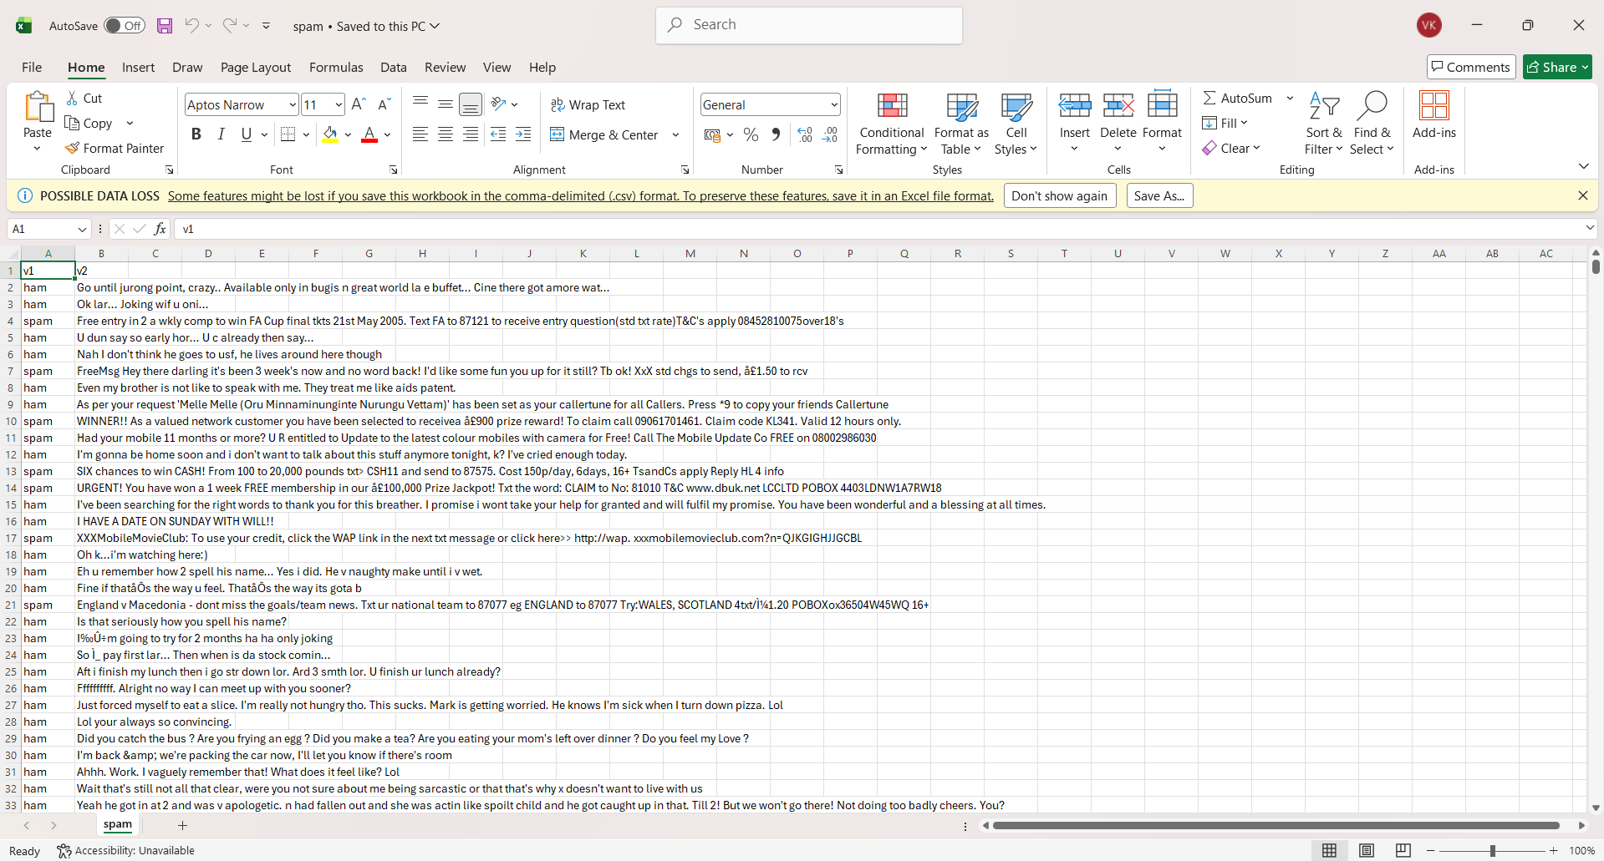

- CODE:
- #include <bits/stdc++.h>
- using namespace std;

- //50 spam keywords taken from the spam.csv dataset

- string patterns[50]={
- "win money","free offer","click here","claim prize","urgent",
- "limited time","loan approved","cash reward","work from home","be your own boss",
- "exclusive deal","call now","reply now","free gift","earn money",
- "winner","congratulations","special offer","risk free","bonus",
- "double money","act now","hurry up","subscribe now","buy now",
- "discount","selected","guaranteed","cheap rate","investment",
- "lottery","reward now","free cash","easy income","no cost",
- "claim now","instant loan","extra income","offer ends","text now",
- "visit now","password reset","verify account","bank details","miracle cure",
- "no obligation","gift card","trial offer","free entry","jackpot"
- };

- string toLower(string s){
- for(int i=0; i<s.length(); i++)
- s[i]=tolower(s[i]);
- return s;
- }

- //search using RabinKarp
- int rabinKarp(string text){
- int i;
- int count=0;

- text=toLower(text);

- for(i=0; i<50; i++){
- if(text.find(patterns[i])!=string::npos){
- cout<<patterns[i]<<", ";
- count++;
- }
- }

- return count;
- }

- //aho corasick
- struct Node{
- int next[26];
- int fail;
- int output;

- Node(){
- int i;

- for(i=0; i<26; i++)
- next[i]=-1;

- fail=0;
- output=0;
- }
- };

- Node trie[3000];
- int sizeTrie=1;

- //putting in pattern
- void insertWord(string s){
- int node=0;
- int i, x;

- for(i=0; i<s.length(); i++){

- if(s[i]==' ')
- continue;

- if(s[i]<'a' || s[i]>'z')
- continue;

- x=s[i]-'a';

- if(trie[node].next[x]==-1){
- trie[node].next[x]=sizeTrie;
- sizeTrie++;
- }

- node=trie[node].next[x];
- }

- trie[node].output++;
- }

- //building the trie
- void buildTrie(){
- queue<int> q;
- int i, u, v;

- for(i=0; i<26; i++){

- if(trie[0].next[i]!=-1){
- trie[trie[0].next[i]].fail=0;
- q.push(trie[0].next[i]);
- }
- else{
- trie[0].next[i]=0;
- }
- }

- while(!q.empty()){

- u=q.front();
- q.pop();

- for(i=0; i<26; i++){

- v=trie[u].next[i];

- if(v!=-1){
- trie[v].fail=trie[trie[u].fail].next[i];
- q.push(v);
- }
- else{
- trie[u].next[i]=trie[trie[u].fail].next[i];
- }
- }
- }
- }

- //search text
- int ahoSearch(string text){

- int node=0;
- int i, x;
- int count=0;

- text=toLower(text);

- for(i=0; i<text.length(); i++){

- if(text[i]==' ')
- continue;

- if(text[i]<'a' || text[i]>'z')
- continue;

- x=text[i]-'a';

- node=trie[node].next[x];

- count=count+trie[node].output;
- }

- return count;
- }

- //main
- int main(){

- cout<<"C VISHWAJEET KUMAR"<<endl;
- cout<<"24BCE0341"<<endl;
- cout<<"CS-1 REAL TIME SPAM DETECTION SYSTEM"<<endl;
- cout<<"RABIN KARP VS AHO-CORASICK"<<endl;

- int i=0;
- string line;

- ifstream file("C:\\sem4 projects\\spam.csv");

- if(!file){
- cout<<"File not found"<<endl;
- return 0;
- }

- //building trie
- for(i=0; i<50; i++)
- insertWord(toLower(patterns[i]));

- buildTrie();

- int msgNo=1;

- while(getline(file,line))
- {
- cout<<"\nMessage "<<msgNo<<endl;
- cout<<"Text: "<<line<<endl;

- //measuring time for rabin karp
- clock_t start1=clock();

- cout<<"Matched Words: ";
- int rk=rabinKarp(line);

- clock_t end1=clock();

- double time1=double(end1-start1)/CLOCKS_PER_SEC;

- cout<<endl;
- cout<<"Total Matches: "<<rk<<endl;
- cout<<"Time Taken: "<<time1<<" sec"<<endl;

- //aho corasick
- clock_t start2=clock();

- int ac=ahoSearch(line);

- clock_t end2=clock();

- double time2=double(end2-start2)/CLOCKS_PER_SEC;

- cout<<"Aho Corasick Total Matches: "<<ac<<endl;
- cout<<"Time Taken: "<<time2<<" sec"<<endl;

- if(rk>0 || ac>0)
- cout<<"SPAM MESSAGE!! CAUTION !!"<<endl;
- else
- cout<<"NORMAL MESSAGE!"<<endl;

- msgNo++;

- if(msgNo>20)
- break;
- }

- file.close();

- return 0;
- }

- ScreenShot:
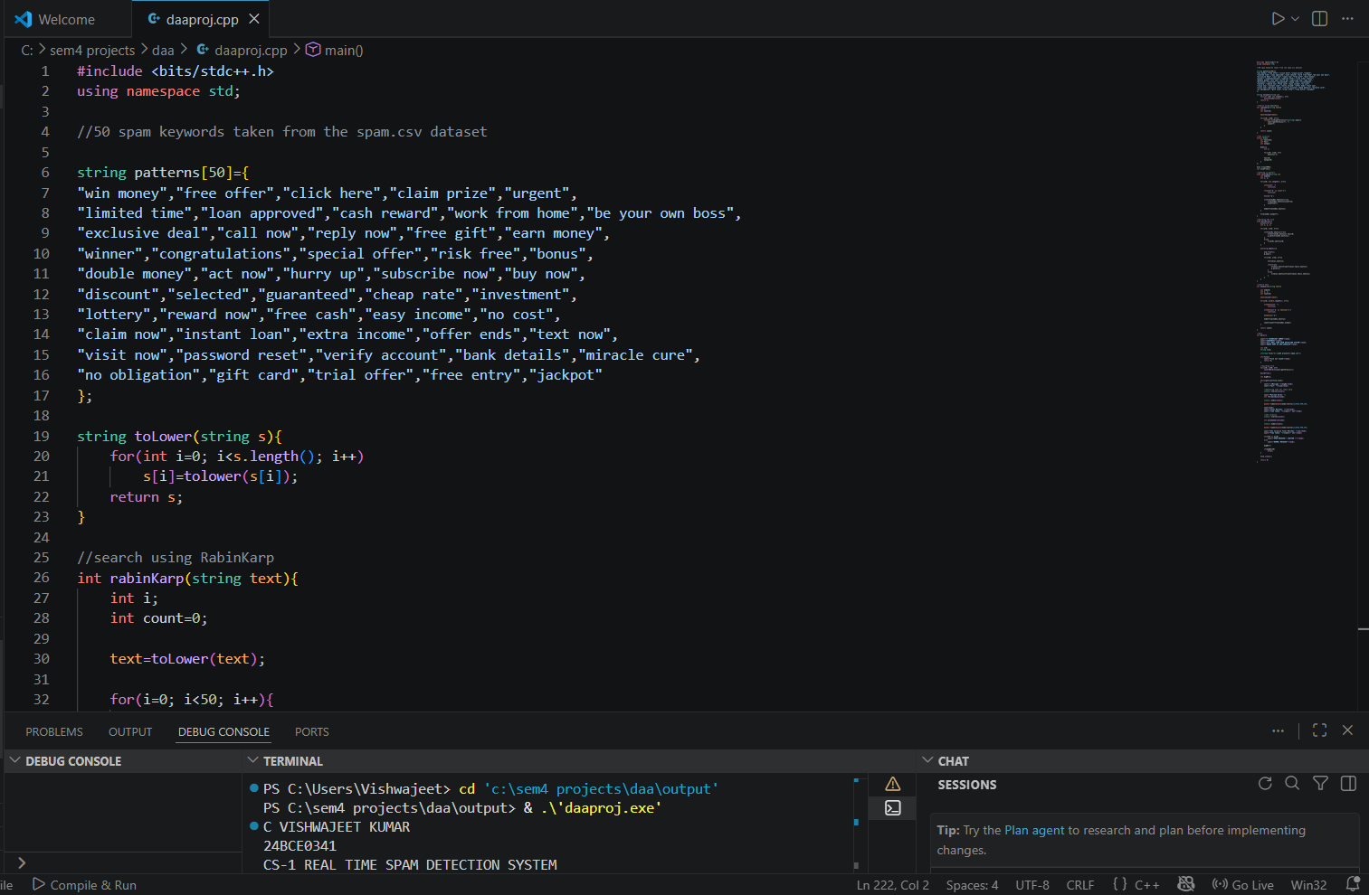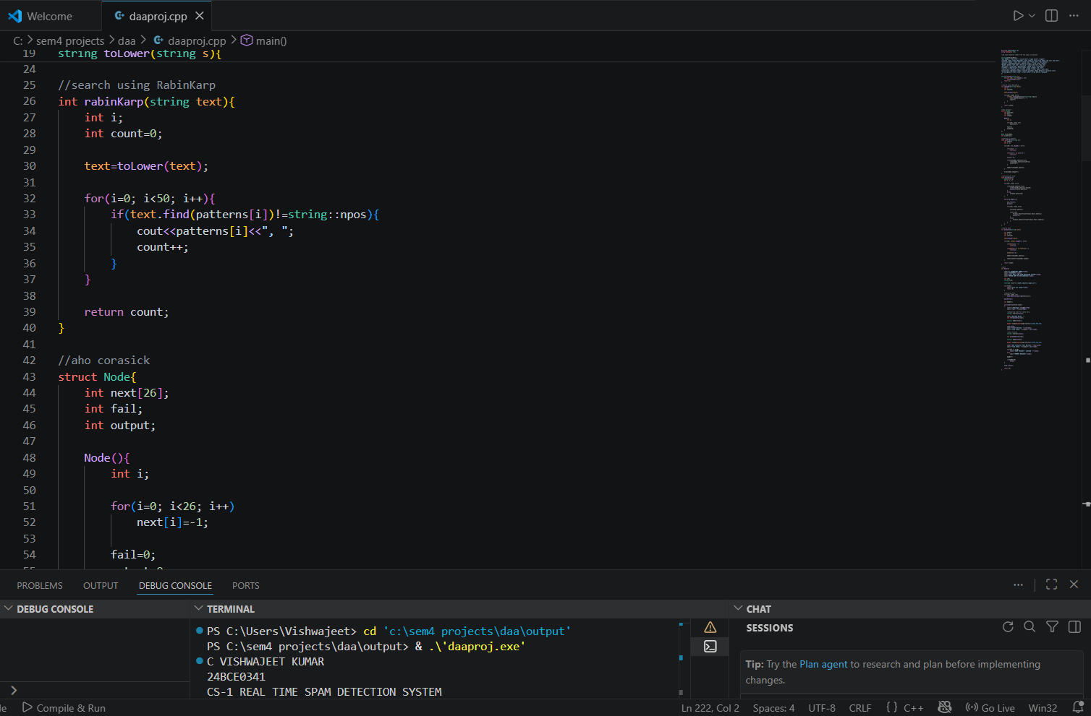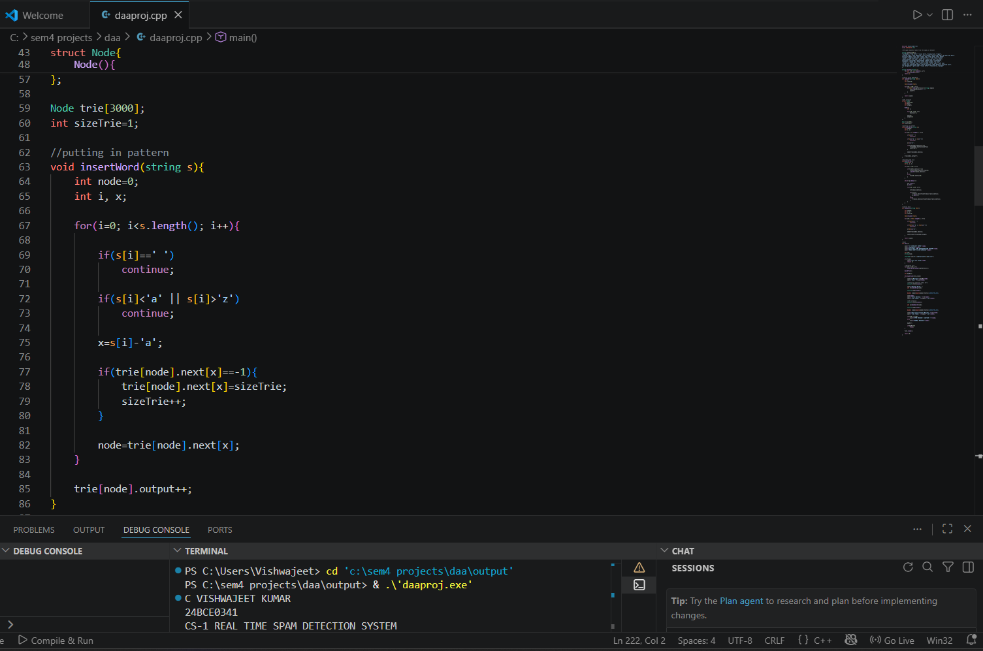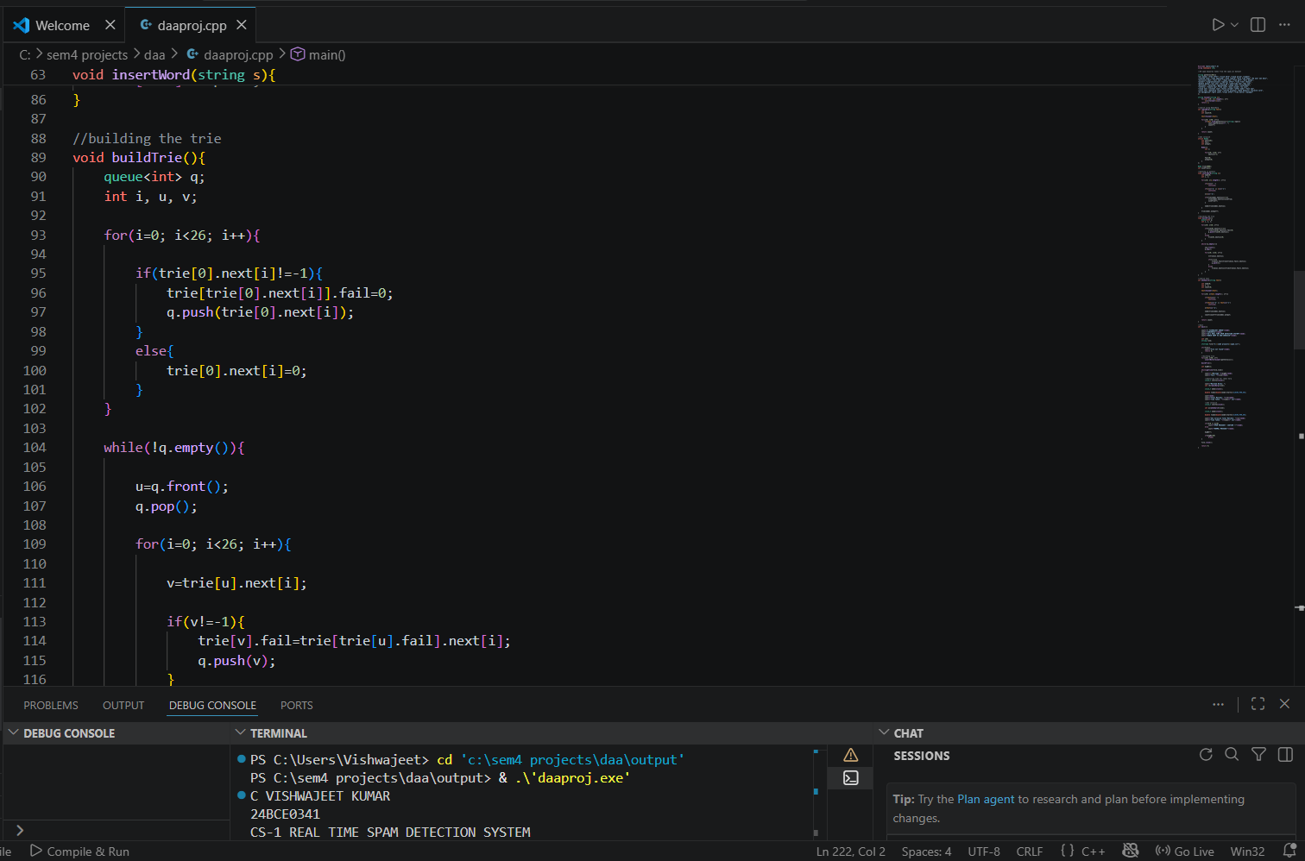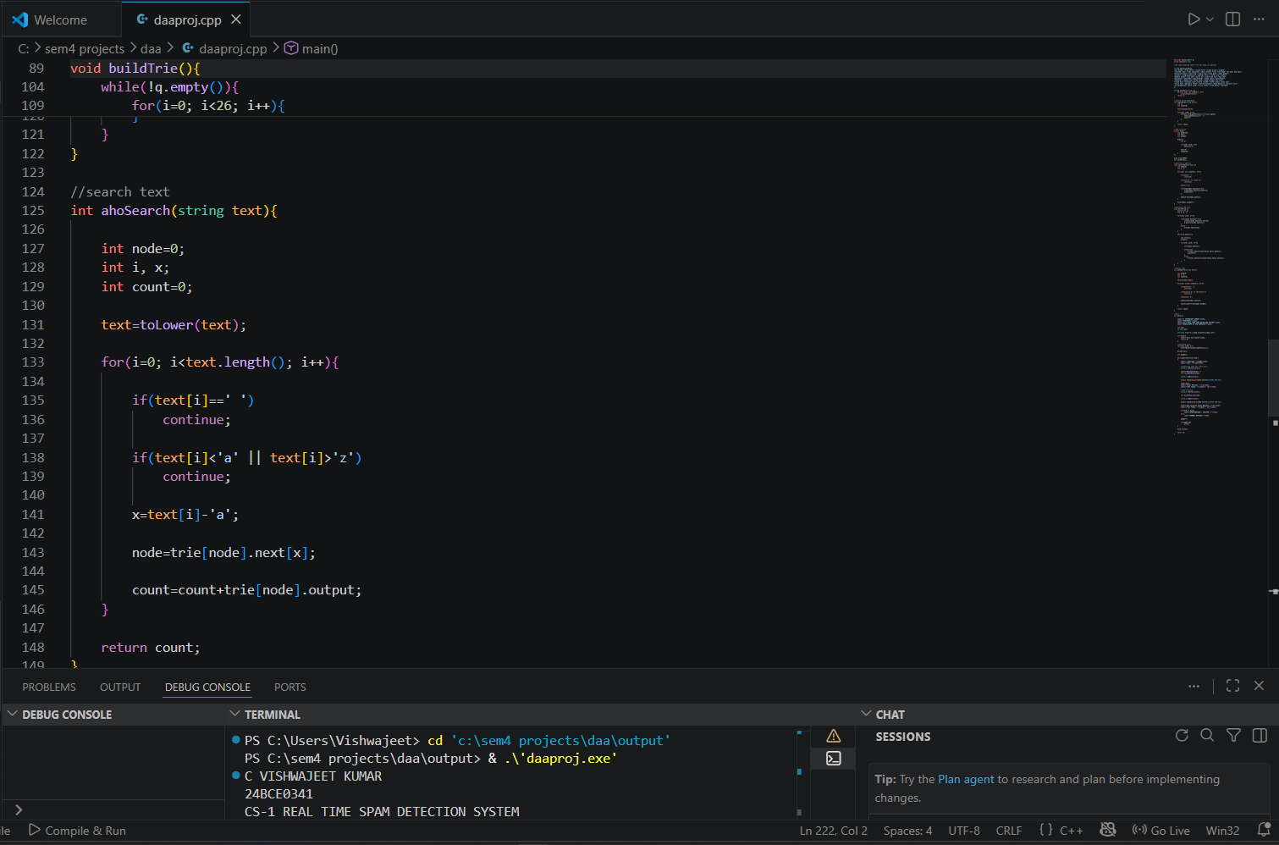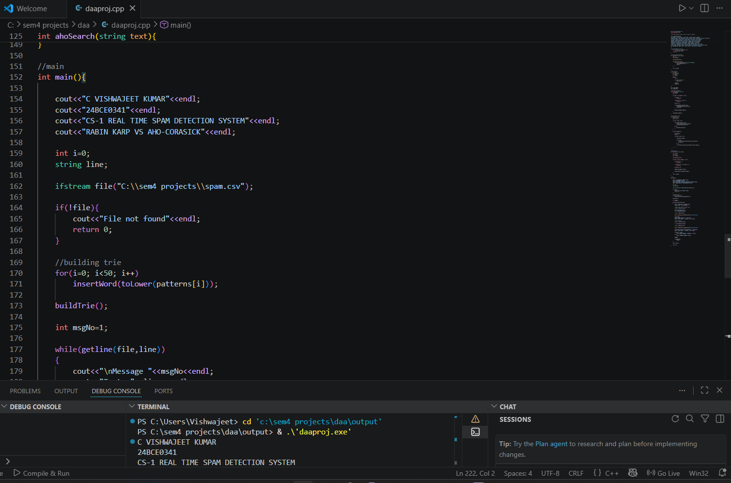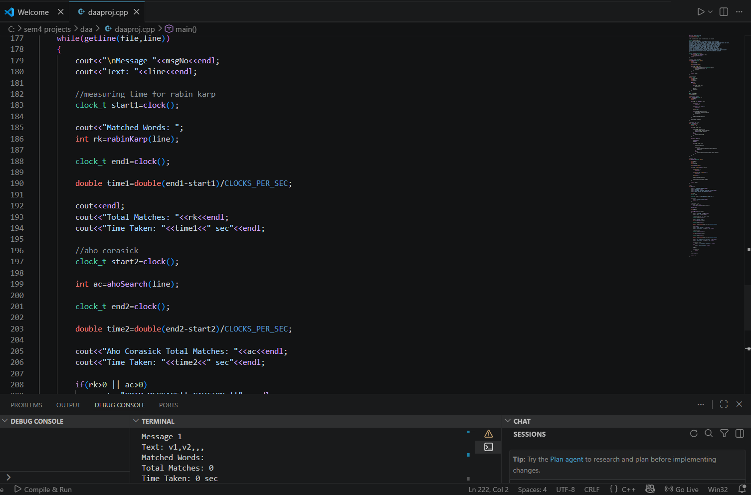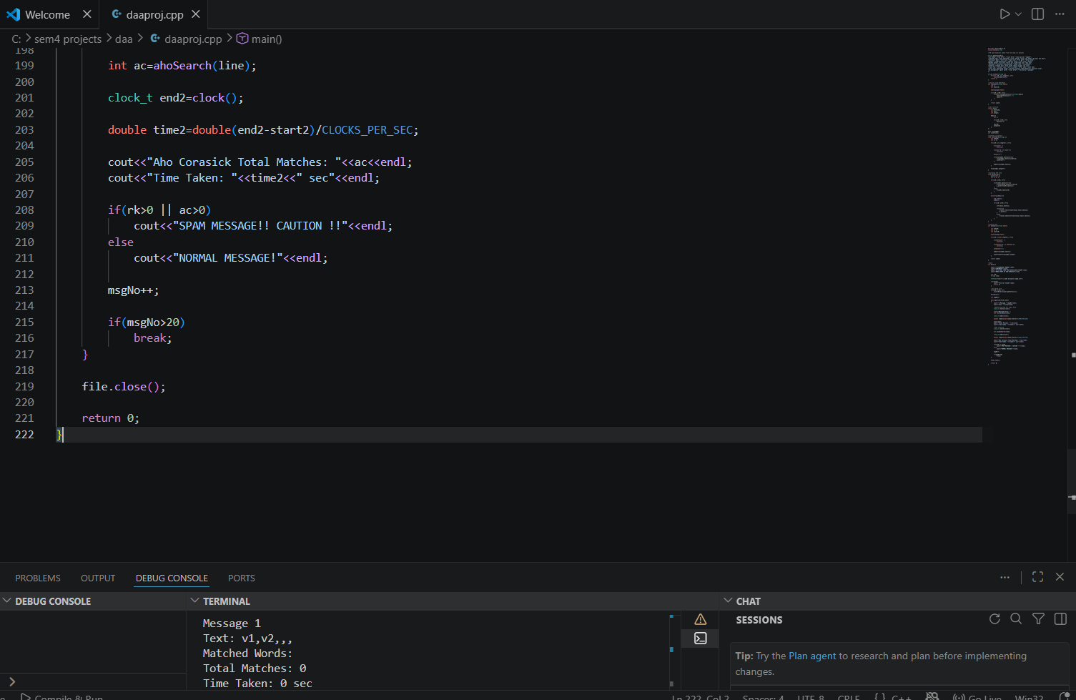

OUTPUT:
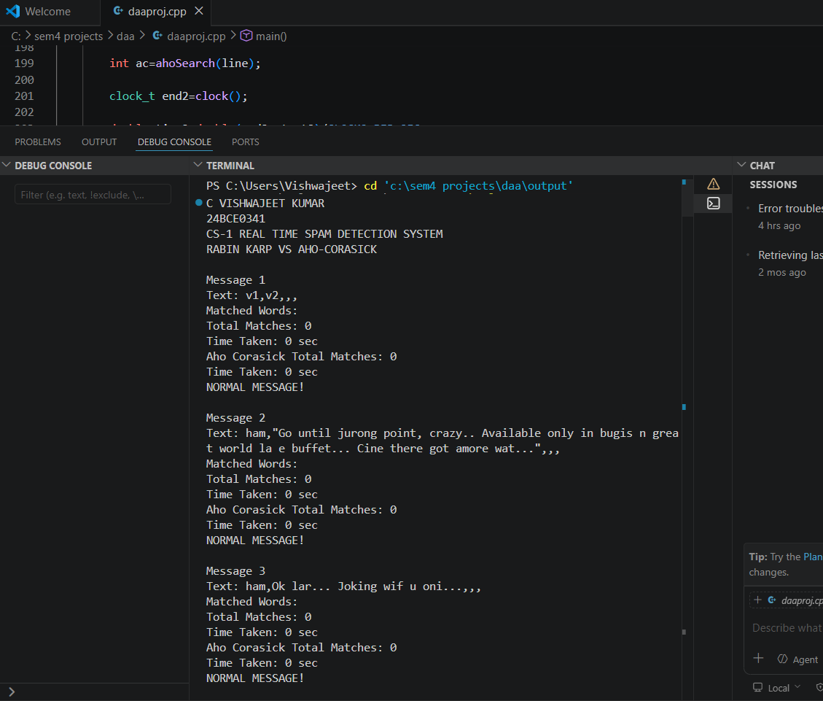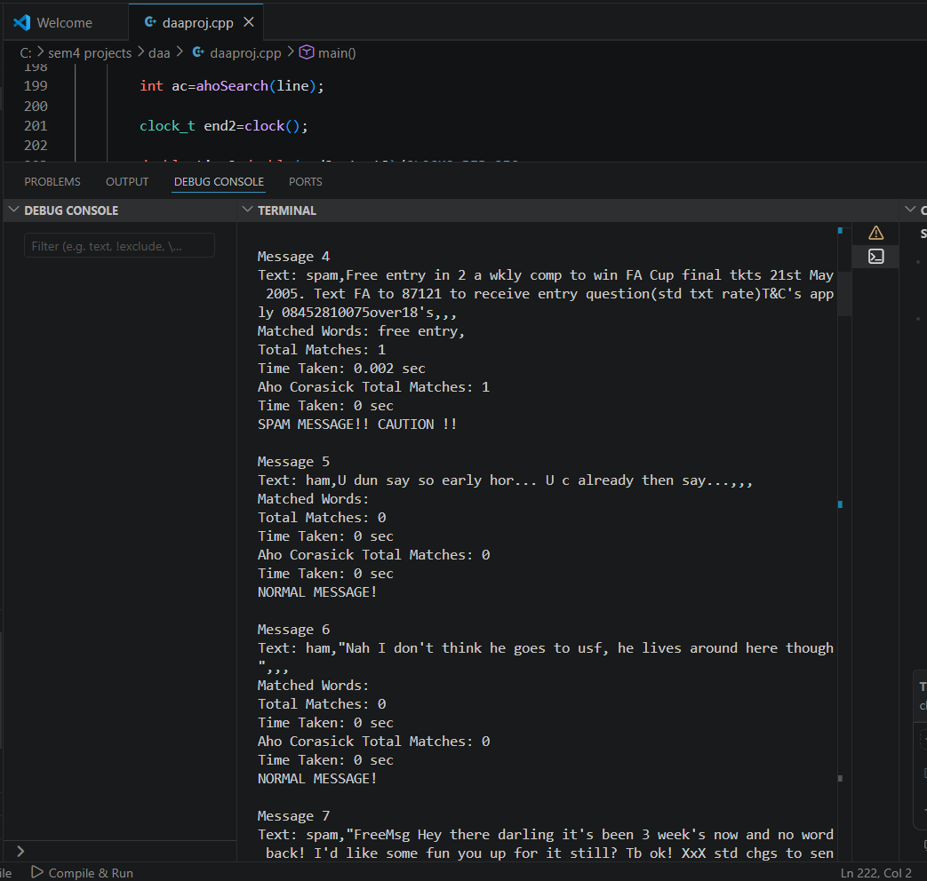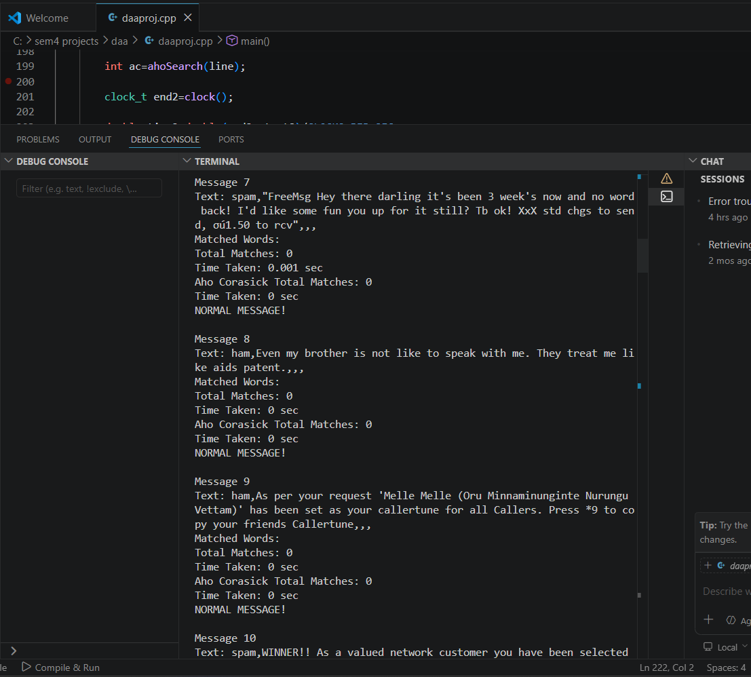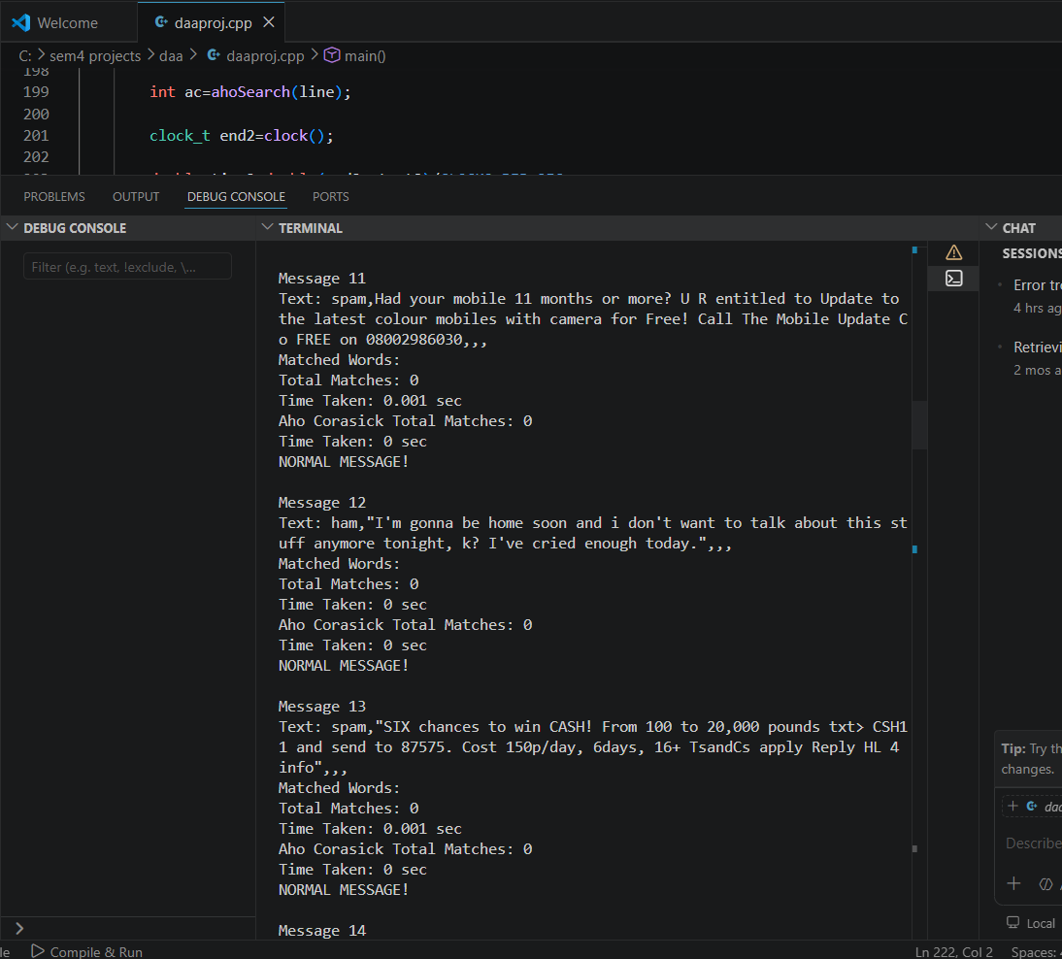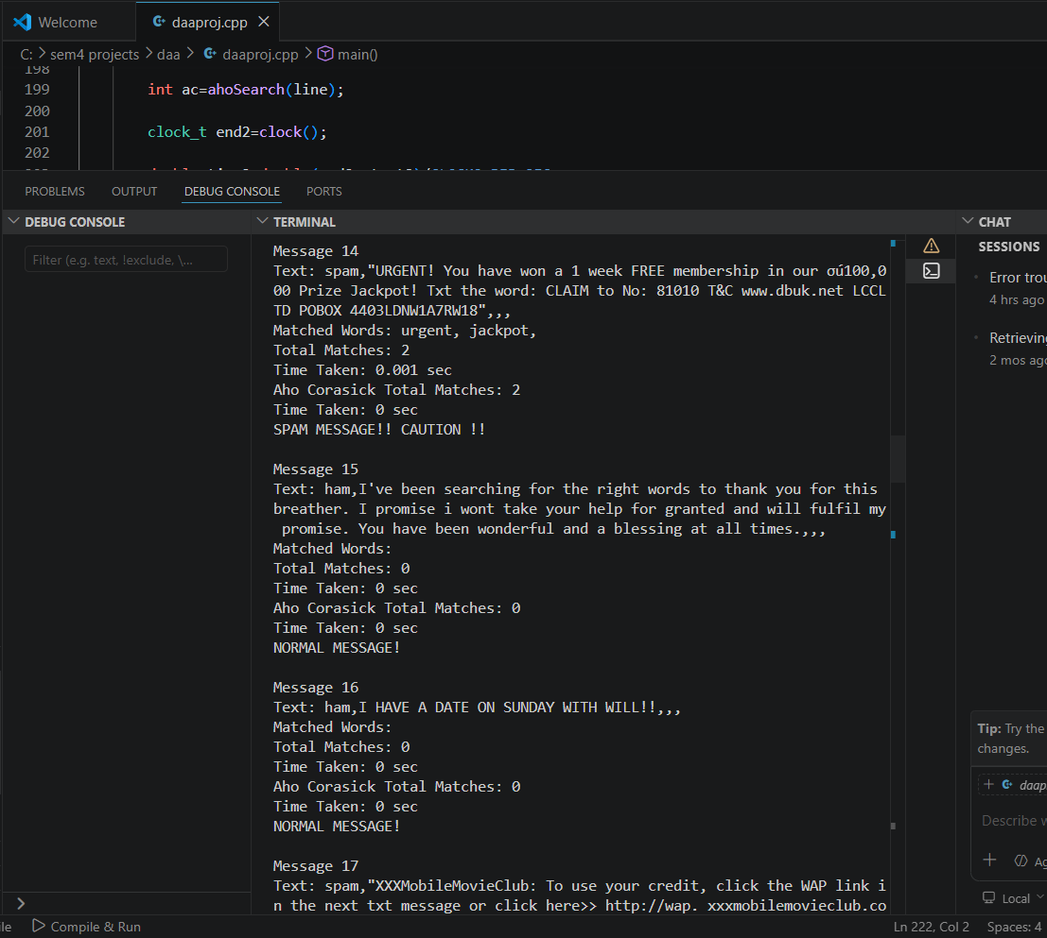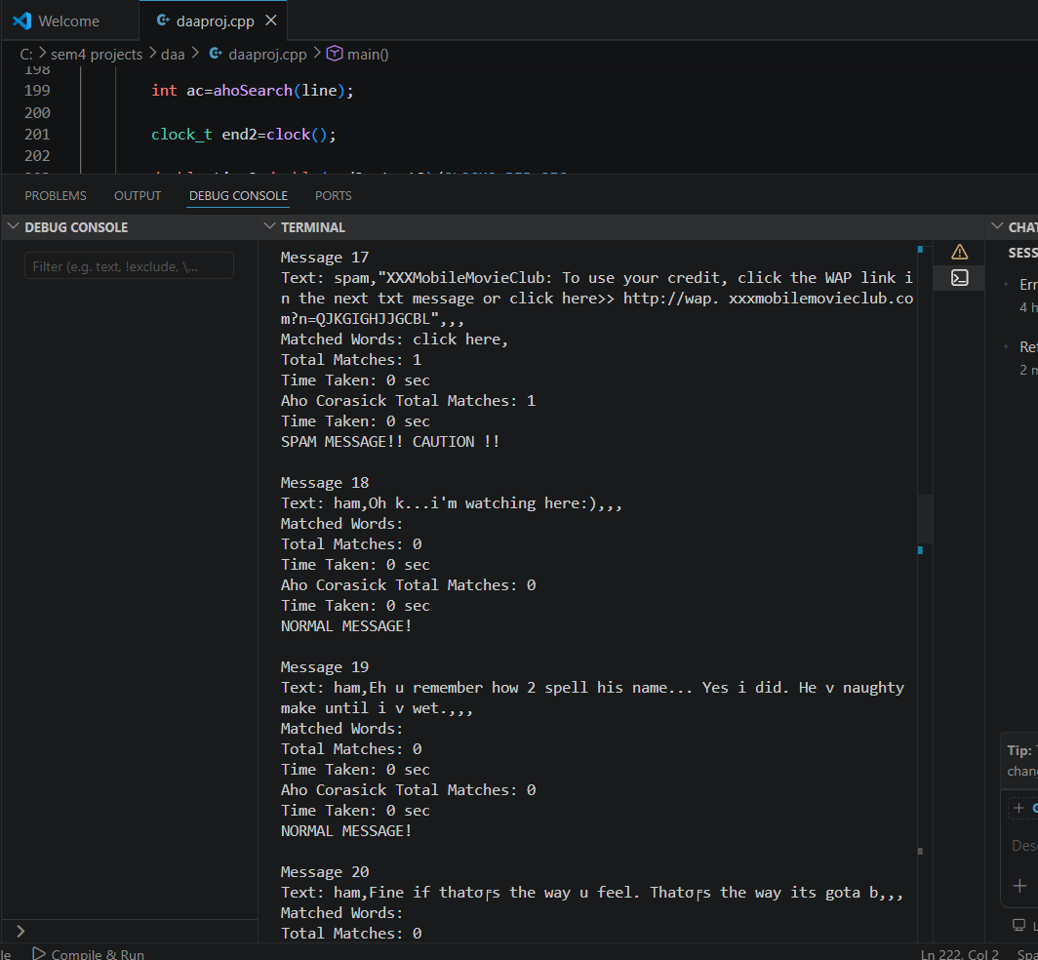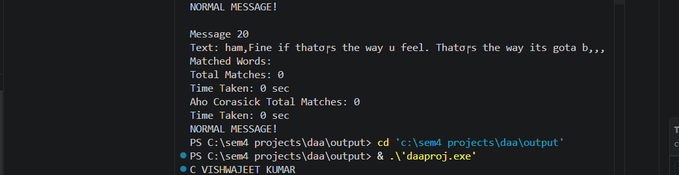

- Analysis:

  - Performance vs Number of Patterns:
When the number of spam keywords increases, Rabin Karp becomes slower because it checks each pattern separately. Aho Corasick remains faster because it searches all patterns together in one scan. Therefore, Aho-Corasick is better for large number of Pattern.

7.2 Performance vs Text Size:
For small messages, both algorithms work fast. For large messages such as long emails, Rabin Karp takes more time, while Aho-Corasick remains efficient because it scans the text only once. Hence, Aho-Corasick performs better for large text.

7.3 Real Time Behaviour:
In real time spam filtering, messages must be checked instantly. Rabin Karp may slow down when many keywords are used. Aho Corasick gives faster response time and is suitable for live systems.

  - Memory Usage:
Rabin karp is simple and memory efficient but aho corasick is faster and better for real time spam detection

- Conclusion and Inference:
Conclusion:
- This project successfully implemented a Real Time Spam Detection System using Rabin–Karp and Aho–Corasick algorithms.
- Both algorithms were able to identify predefined spam keywords from incoming messages such as emails, SMS, and chat texts.
- Rabin–Karp performed well when the number of keywords and message size were small. It is simple to implement and uses less memory.
- As the number of spam patterns increased from 50 to 500, Rabin–Karp required more processing time because each pattern was searched separately.
- Aho–Corasick showed better efficiency by matching multiple patterns simultaneously in a single scan of the text.
- It provided faster execution time for large messages and larger keyword sets.
- Although Aho–Corasick uses more memory due to trie and failure links, its speed advantage makes it highly suitable for practical systems.
- Therefore, for modern spam filtering applications where fast response is important, Aho–Corasick is the better choice.

Inference:
- For small-scale systems with limited keywords, Rabin–Karp can be used effectively.
- For large-scale spam detection with hundreds of keywords, Aho–Corasick performs much better.
- If memory resources are limited, Rabin–Karp is preferable.
- If speed and real-time performance are the main priorities, Aho–Corasick is the ideal algorithm.
- Increasing text size affects Rabin–Karp more than Aho–Corasick.
- Increasing number of patterns has minimal effect on Aho–Corasick after trie construction.
- Aho–Corasick is more scalable for future expansion of spam keyword databases.
- Real-world email and messaging platforms would benefit more from Aho–Corasick based filtering systems.
- The project proves that algorithm selection depends on system requirements such as speed, memory, and data size.
- Overall, Aho–Corasick is recommended for real-time spam detection systems.

PS: GITHUB LINK: https://github.com/wejew2983/DAA_project_SpamDetection

